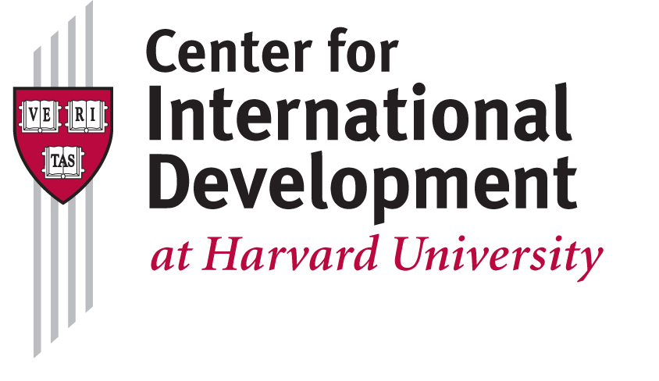
CID’s Undergraduate Internship Program
2015-16 Academic Year

The Center for International Development is a university-wide center that works to advance the understanding of development challenges and offer viable solutions to the problems of global poverty. CID is Harvard’s leading research hub focusing on resolving the dilemmas of public policy associated with generating stable, shared, and sustainable prosperity in developing countries. CID has consecutively been named one of the top five global think tanks in international development.

CID’s Undergraduate Internship Program runs each semester with the possibility of extension through the academic year and summer months. Interns are paid hourly rates based on experience and university student pay guidelines. The program provides students the opportunity to learn about and contribute to business operations for a global research center in the field of international development. The successful candidate will work closely with our energetic and friendly CID staff, gain an understanding of the functions and dynamics of the non-profit sector, and work in a high-profile, fast-paced office. Depending on skills set and interest, interns will be given an opportunity to work on research projects.

Description
We are looking for a creative and assertive intern that can consistently work six to ten hours per week, negotiable. The ideal candidate will:
- Support research team with literature review, proofreading materials, drafting letters and briefings;
- Assist the data and visualization teams in cleaning, analyzing, and presenting trade and international development datasets;
- Provide operational support to office management functions including assisting the front desk and proofreading faculty course materials;
- Research and prepare material for key meetings including briefings and agendas;
- Draft and edit donor materials including reports, briefs and center materials; andConduct other miscellaneous tasks related to the ongoing activities of a research center.

To be eligible for our Internship Program, applicants must meet the criteria below:
- Proficiency in MS Office (particularly Excel and PowerPoint) and web-search skills;
- Excellent written and verbal communication skills; and
- Experience working on events and workshops.

Preferred qualifications:
- Desire to learn more about international development;
- Proactive, collaborative and able to deal with different stakeholders (internal and external) in a fast paced environment;
- Ability to plan and work on multiple projects simultaneously in an organized way;
- Team player with cultural sensitivity;
- Knowledge of any graphic design software (Photoshop, Illustrator); and
- Knowledge of data processing packages such as Stata or Matlab, or an interest in learning to code with programming languages such as R, Python or Javascript.

How to Apply
Candidates should email resume and cover letter to Chuck McKenney at cid@hks.harvard.edu with ‘Intern 2015/16’ in the subject line. Applications will be reviewed on a rolling basis until the position is filled.

